**NAALAIYA THIRAN**

**REPORT WEEK 5**

Domain: ARTIFICIAL INTELLIGENCE

Project: AI-powered Nutrition Analyzer for Fitness Enthusiasts

Team Leader :SOORAJ K

Team member : RAM BALAJI

Team member :PRASSANA KUMAR

Team member : PRAVEEN RAJ S

Team member : RITHVIK THOTA

* **Prepare the proposed solution document, which includes the novelty, feasibility of idea, business model, social impact, scalability of solution, etc.**

Submitted the proposed soultion in the prescribed template in GitHub

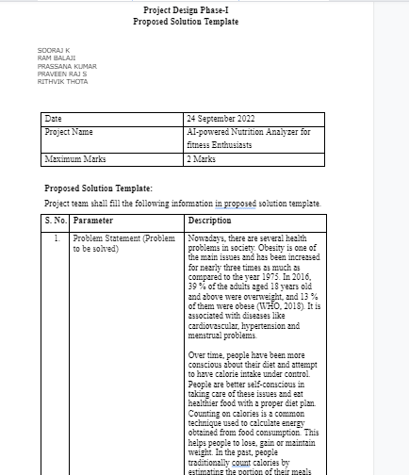

* **Attend the training , Attempt the Quiz-2 & Submit the Assignment-2**

Attended the training , and Attempted the Quiz-2 & Submitted the Assignment-2